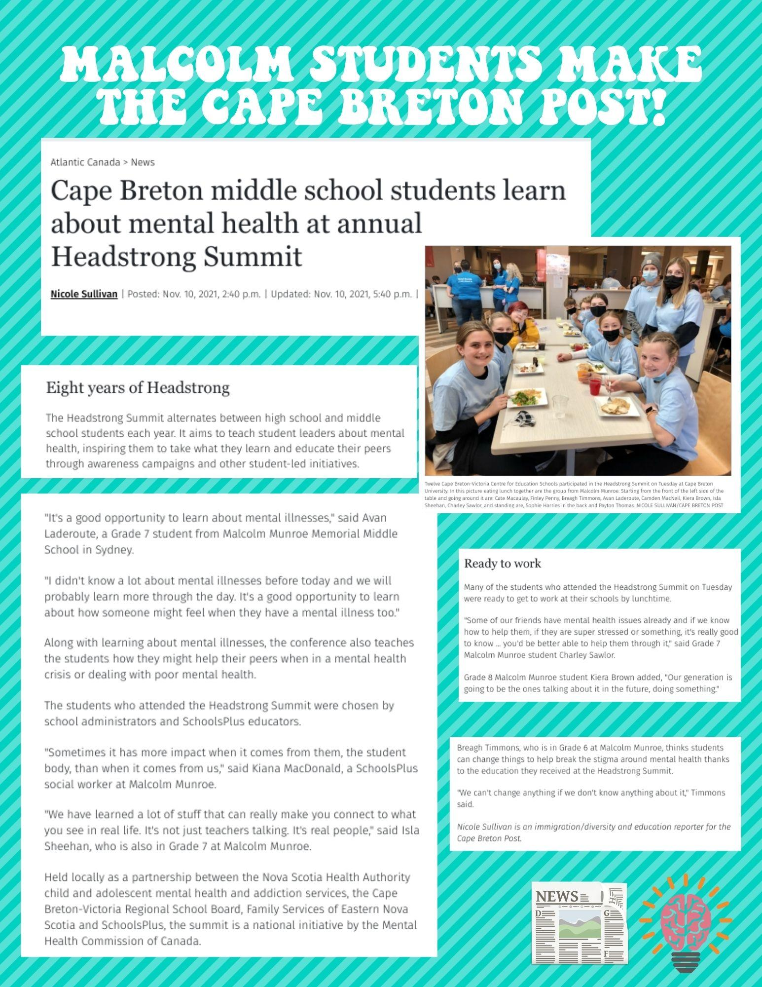

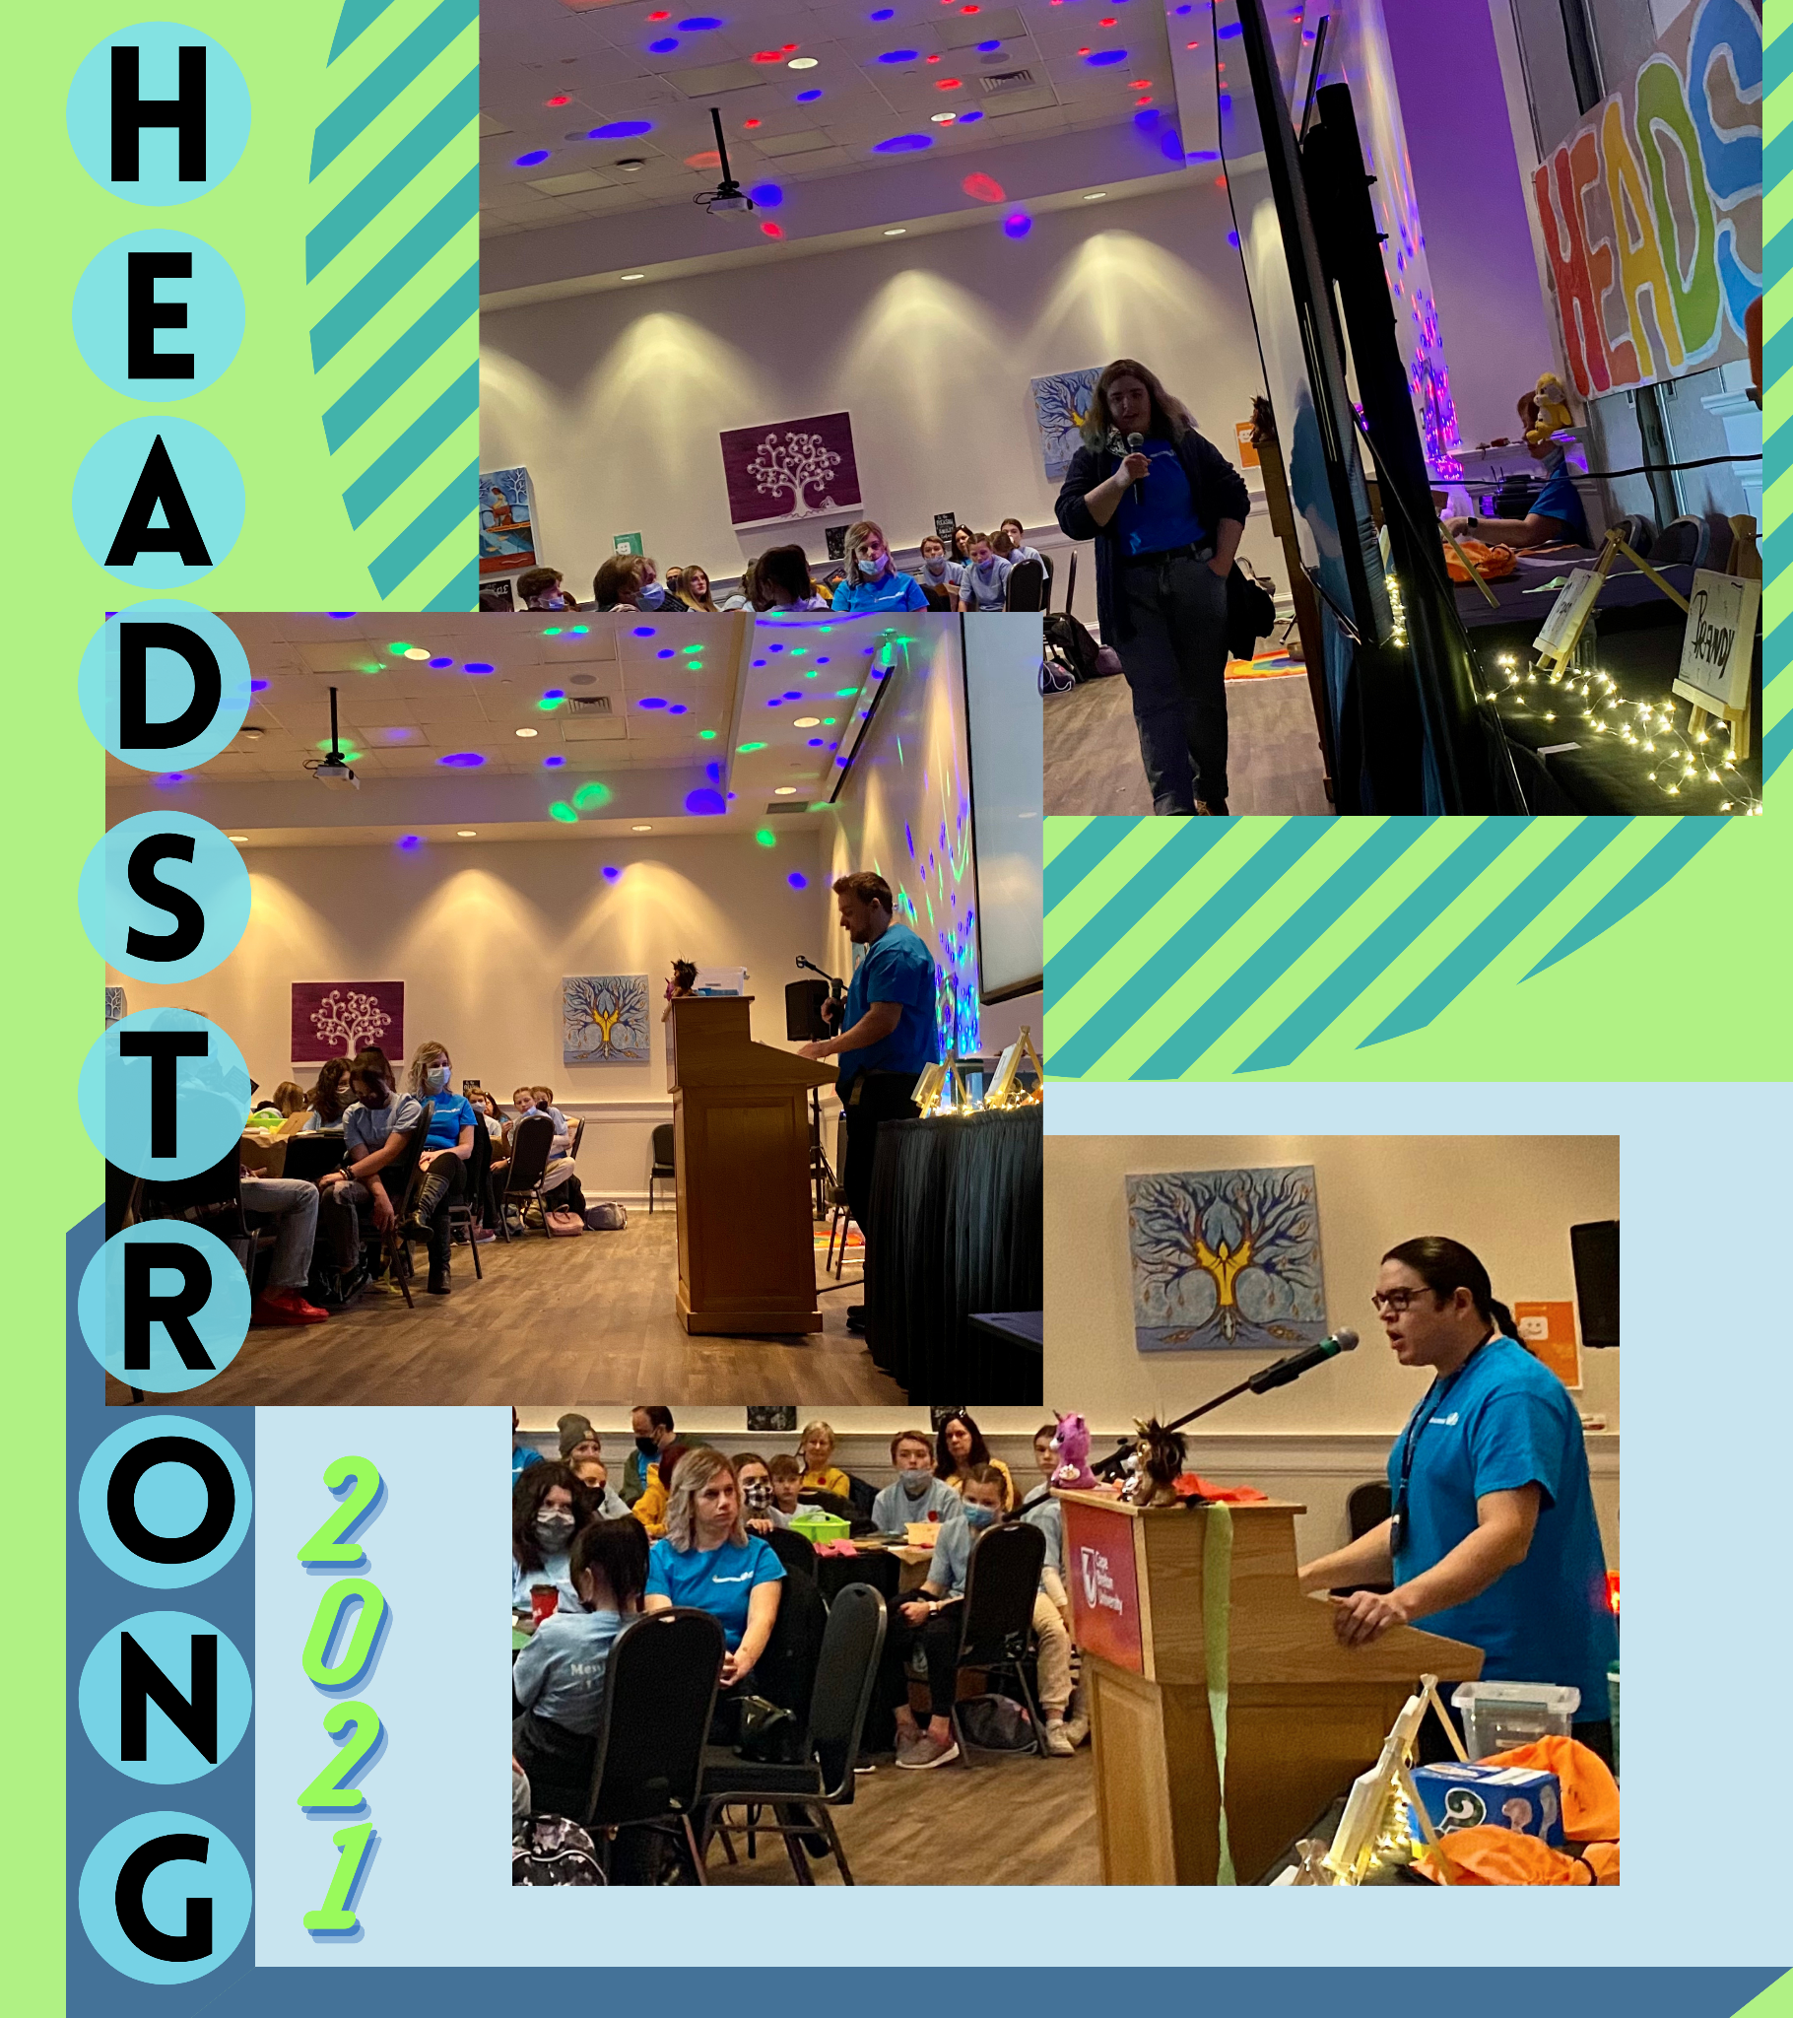
On November 9th, 2021, SchoolsPlus hosted its 8th annual HeadStrong Anti-Stigma Summit and its 5th Summit at CBU. We had 75 middle school students across the CBVRCE join us for this event! The summit focused on education about mental health and the impacts of stigma. The goal was to increase knowledge of mental illness and addictions, decrease stigma, and change current attitudes about mental health. Through first voice stories the students were able to learn of first hand experiences of people living with mental illness and addictions and their journey to hope and recovery. Students were involved in action planning and how to become champions of change by bringing what they learned on this day about mental health to their peers in their middle-schools!

