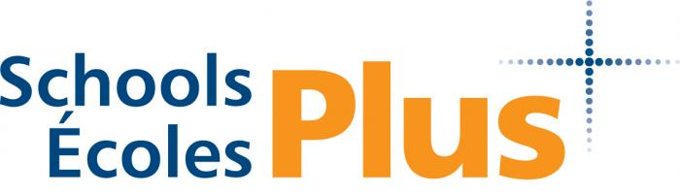

FALL 2021: FREE Incredible Years Parent/Teacher Training Program

The INCREDIBLE YEARS Training Series has been extensively researched and field tested with over 2000 families. It has been proven to reduce children’s behavior problems and increase pro-social behaviors. Parents report that they feel more confident and comfortable with their parenting skills after completing the training.

Goals of the Incredible Years Parenting Program are:
- Promoting child social competence, emotional regulation, academic readiness and problem solving skills
- To prevent and reduce behaviour and emotional concerns in young children
- To improve our parent-child interactions, build positive relationships and attachments, improve parental functioning by using more nurturing methods, and increase parental social support and problem solving
4 locations, register with the one that meets your needs:
Gas cards available upon request for anyone with transportation barriers
Queens County  Dates: Wednesdays, beginning Nov 3 and ending Dec 7th 4:30-6pm  Where: Dr JC Wickwire Elementary  Supper meal and Child care provided  To register call/email Shannon Vincent 902 523 1451, svincent@ssrce.ca | Bridgewater  Dates: Thursdays Nov 4, Nov 18, Dec 2, Dec 9th 10-12  156 York Street, (Previously the Bridgewater Family Support Centre)  Snacks and refreshments provided  To register call/email Melissa Chiasson 902 521 9786 , mchiasson@ssrce.ca
New Ross  Dates: Mondays, Nov 1, 15th, 29th, Dec 13th, 9:30-11:30  New Ross Family Resource Centre  Snacks and refreshments provided  To register call/email Clare Power 902 523 2917 cpower@ssrce.ca or Sarah Julian 902 930 3461 sjulian@ssrce.ca | 2022 For Parents of children 3-6 years  Dates: January-March (12 weeks)  Where :Bridgewater Area (TBA)  To register contact Amy Foster 902 523 5731, afoster@ssrce.ca or Sally Tanner 902 350 3739, stanner@ssrce.ca

