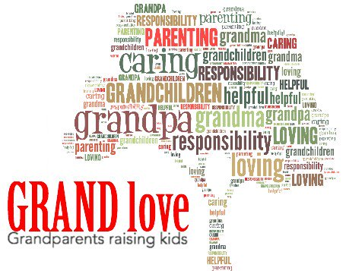

Grandparent
Support Group
Finding oneself in the role of parenting again can be overwhelming as well as extremely rewarding. Grandparents bring wisdom and lessons learned approach to parenting.

If you are a grandparent raising or helping to raise your grandchildren please join us for tea/coffee to help with some of the challenges that come with this role.

When:
Monday, October 7, 21 & 28, November 4, 18 & 25 (With December 2, 2019 being a “make up Day”)
10:00 am – 12:00 pm

Where:

Lawrencetown Education Center/ Family Matters Community Room
10 Middle Road, Lawrencetown, NS

Contact:
For more information please contact:
Krista Steele SchoolsPlus Community Outreach (Middleton – Lawrencetown Area) 902- 824- 5379 office or 902-824-4057 cell
Krista.steele@avrce.ca
Leah Marshall SchoolsPlus Community Outreach (Lawrencetown – Cornwallis Park Areas) 902-532- 3299 office or 902- 526-3535 cell
Leah.marshall@avrce.ca
** Please note you can call or text **

** Childcare available (Please pre-register for this through Krista/Leah) ** ** Limited Transportation Assistance Available (Form of Gas Cards/Bus tickets) **
Name of Amazing GRANDPARENT Participant:
_____________________________________
Mailing Address:
____________________________________________________ ____________________________________________________
E-Mail Address: ____________________________________________________
Phone Number: ____________________________________________________
Names and ages of Grandchildren: Childcare Needed:
______________________________________ Y / N
______________________________________ Y / N
______________________________________ Y / N
General Consent to Use Photograph
SchoolsPlus Annapolis, Annapolis Valley Regional Centre for Education, may take photographs of parents and students to showcase special events and activities that take place throughout the year. There may be times that SchoolsPlus will want to promote an event or achievement and use photographs in newsletters, news releases, Education Centres or Provincial SchoolsPlus web pages, displays or pamphlets.
Pursuant to the Freedom of Information and Protection of Privacy Act, Clause 26(b)
I, ________________________________, of _________________________________
Do hereby give consent to SchoolsPlus Annapolis to approve the release of images.
Signature of Consenting Adult _______________________________________________
Name of Child (ren) if needed __________________________________________________
Dated: ________________________________________________________________

