​
FREE2BU

Free2BU - an eight week program for any student in Grade 7 or 8 that focuses on promoting healthy living and allows participants to explore, develop, and discover their strengths. Free2BU encourages participants to celebrate their differences and to connect with their commonalities. This program includes activities that are experiential, fun, and interactive. A discussion component is included to give participants an opportunity to connect on a personal level and to discuss issues that are important to them. Participants will explore and discuss specific topics in a safe, confidential, and encouraging environment.

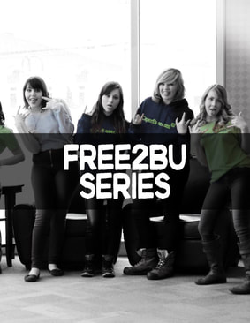

When: Every Wednesday from Oct 10 - Dec 5 from 1:15-2:45
Where: EMS Schools Plus office
Who is offering it: School Counsellor & NS Health
Who is it for: Any student in grade 7 or 8

I would like to participate!

Name: _______________________________________________

Home room: ___________________________________________

Do you have any food allergies or sensitivities that we should be aware of?

_________________________________________________________

There is limited enrollment so be sure to sign up!
If you have questions check with School Counsellor Mary Hanneman

