FREE Arts & Crafts Program
SchoolsPlus will be hosting an Arts & Craft Session for Grades 4 to 6 students
who attend schools in Digby County

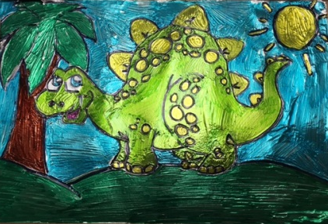
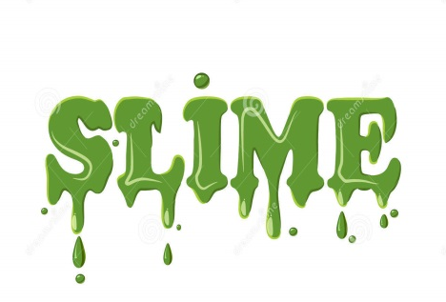
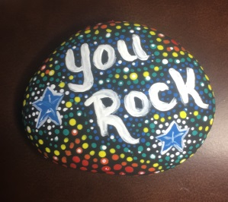

Tinfoil Art Rock Painting Slime Making

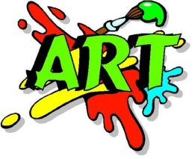
Date: Monday, March 12th, 2018

Time: 10:00 a.m. to noon

Location: Digby Regional High School

Maximum of 10 Participants!

To register, contact:

Amy Theriault at 902-245-7507

Or

Janice Cromwell at 902-245-7524

(Registration on a first come, first served basis!)

