**SchoolsPlus Annapolis,**

Along with the ***talents*** of, **Mrs. Lori Whitman – Price**

**Would like to Help you “beat the Winter Blues”**

By offering a ***FREE***

**LUNCH - N – LEARN**

**On RUG HOOKING.**

(Image below – All needed supplies will be provided – NO EXPERIENCE NECESSARY)

**This 4 week session is open to any Junior/Senior High students at BRCS.**

**(Space is limited to 10 – so sign up early)**

**It will be held each Wednesday from 11:30 – 12:15pm in the ART STUDIO.**

**Starting:** **Wednesday, February 7, 2018** and running until Wednesday, February 28, 2018

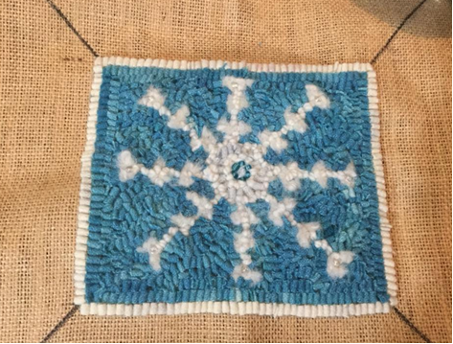

Sign up is located in the BRCS office.

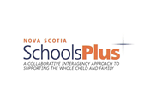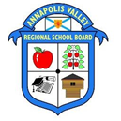 [](https://www.google.ca/url?sa=i&rct=j&q=&esrc=s&source=images&cd=&ved=0ahUKEwiP9rWP6tzYAhWH5oMKHUsVCdsQjRwIBw&url=https://www.caphc.org/no-baby-unhugged/&psig=AOvVaw2_XMCmV-XtlrM1eiFZKz-C&ust=1516203972565969)

**“BEAT THE WINTER BLUES”**

**With SchoolsPlus Annapolis & Mrs. Whitman-Price**

**Wednesday, January 7, 2018 – Wednesday, January 28, 2018**

**11:30 – 12:15pm**

NAME: HOMEROOM:



------------------------------- WaitList -----------------------