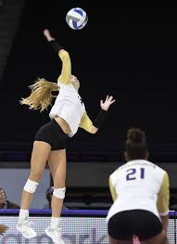

**THIS CLINIC IS AVAILABLE FOR FEMALE VOLLEYBALL PLAYERS WHO WILL BE PLAYING HIGHSCHOOL VOLLEYBALL IN THE 2019/2020 SCHOOL YEAR. THERE WILL BE 20 SPACES AVAILABLE. FIRST COME FIRST SERVE.**

**IF INTERESTED**

**PLEASE CONTACT**

**LINDSAY LATHAM AT 902-574-0001 or llatham@gnspes.ca**

**FREE CONDITIONING CLINIC**

**AUGUST 26-30, 2019**

**2PM-4PM**

**SYDNEY ACADEMY GYM**

**SYDNEY ACADEMY GYM**

**THIS CLINIC IS AVAILABLE FOR FEMALE VOLLEYBALL PLAYERS WHO WILL BE PLAYING HIGHSCHOOL VOLLEYBALL IN THE 2019/2020 SCHOOL YEAR. THERE WILL BE 20 SPACES AVAILABLE. FIRST COME FIRST SERVE.**

**IF INTERESTED**

**PLEASE CONTACT LINDSAY LATHAM @ 902-574-0001 or llatham@gnspes.ca**

## **IMPROVE YOUR SKILLS**

