<Cond

February 2019

*Amherst SchoolsPlus Monthly Newsletter*



**What is SchoolsPlus?**

SchoolsPlus is a comprehensive and collaborative interagency approach to educating and providing service to the whole child and family, with the school as the center of service.   
  
The focus of Amherst SchoolsPlus is to support referred students and families by helping them attain timely and effective services that meet their identified needs.   
  
Additionally, SchoolsPlus provides a variety of different programs and activities to students and families within the 10 schools it serves (Spring Street Academy, Cumberland North Academy, West Highlands School, Northport Consolidated Elementary, E.B. Chandler Junior High, Amherst Regional High, Springhill Junior/Senior High, Oxford Regional Education Centre, Parrsboro Elementary, and Parrsboro Regional High).

COMMUNITY ROOM DROP-IN  
  
The Community Room is located in room 107 at Amherst Regional High (190 Willow Street).

The Community Room is open to all ARHS students during lunch hour Monday and Wednesdays unless otherwise noted on the Community Room door.

The Community Room is also open each Wednesday after school until 7pm to all E.B. Chandler Junior High and Amherst Regional High School students.

**After School Activity Schedule**

**Wednesday, February 6**

Paint night with Janelle

**Wednesday, February 13**

Snowshoeing, weather permitted

**Wednesday, February 20**

Bingo with prizes

**Wednesday, February 27**

Candle Making

**Feelings Group: Beginning at West Highlands School February 19.**

The feelings program is designed to help students recognize and identify feelings and emotions. It is also provides students with strategic tools they can use when they are frustrated or struggling to cope with a situation. The program is completed throughout six sessions covering the following topics:

* Introduction to feelings and emotions.
* Bottling – Bottling emotions and feelings can be explosive, depressive, and bad for our health. What can we do instead of bottling?
* The anger rules – It’s ok to feel angry but it’s not ok to hurt others, yourself, or property. Don’t forget to talk about whatever is making you angry.
* Time-outs – Removing yourself from an unpleasant situation to give yourself time to calm down.
* Dirty and clean anger – Everybody gets angry. How do we express our anger in safe and healthy ways?

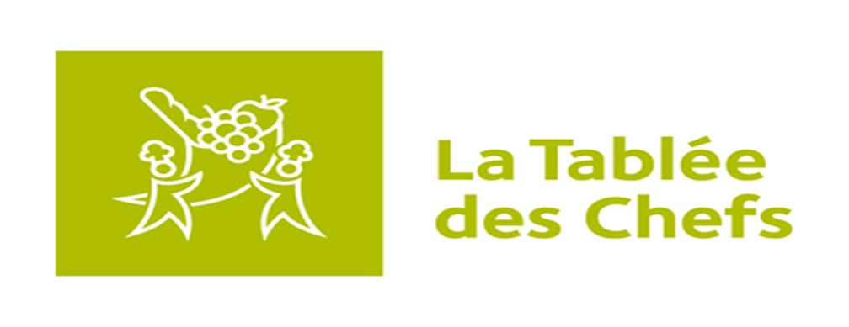**THE Kitchen brigades**

**(Grades 9-12)**

The Kitchen Brigades program consists of 12 culinary workshops, 3 culinary challenges and local, provincial and national iron chef type competitions. The 12 culinary workshops are held as extra-curricular activities from February to May and allow students to develop their culinary skills and food knowledge. The three culinary challenges focus on three main areas of teaching: community engagement, local food sourcing, and an international food fair.

This program will run each Wednesday after school beginning February 13 at Amherst Regional High School. There are only 16 spots available for this program so you must register as soon as possible if you are interested. For more information, contact Marvin Hairston (902) 694-8277.



**COMING SOON: FOOD CLUB AT NORTHPORT CONSOLIDATED ELEMENTARY**

**This 10 week cooking program will educate students around healthy food choices and safe food handling. Students will also document their learning through various media means.**

**This program began at Northport Consolidated Elementary on February 5 and with Photographer, Catherine Bussiere.**

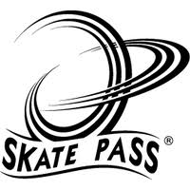

Skate Pass is a program that meets the National Association for Sport and Physical Education (NASPE) activity guidelines, national standards for physical education, and all school safety requirements. The Skate Pass curriculum caters to the New PE, which school systems across the world are embracing. The New P.E. gives students an opportunity to participate in alternative activities in a non-competitive, individual sporting environment.

This program is scheduled to begin at West Highlands School this month. Date to be determined.

**Voices (self-empowerment for girls) program**

The first 9 of 18 sessions for this program has been completed and the group will resume for the following 9 sessions the week of February 11. This program is facilitated by the ARHS Youth Health Centre Nurse and SchoolsPlus Faciliator.

A boys social group at Northport Consolidated Elementary play a game of

mini stick roller hockey on January 30.

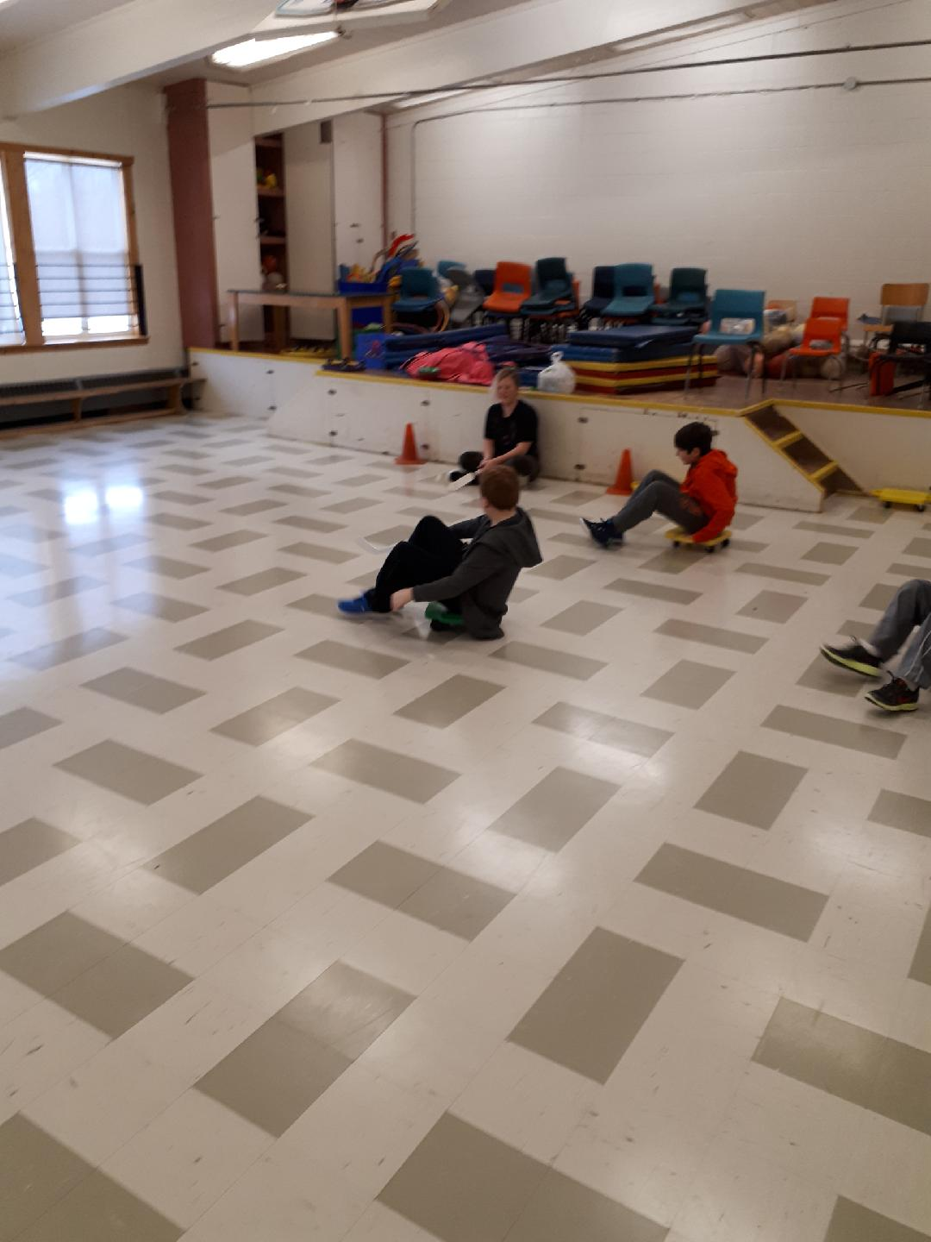

*This student enjoys a warm cup of hot chocolate while playing “Don’t Lose Your Cool”*

Amherst SchoolsPlus is currently running social groups at:

* **Northport Consolidated Elementary**
* **Parrsboro Regional Elementary**
* **Oxford Regional Education Centre**



**Social groups are a great way for students to meet new friends, participate in new activities, and socialize in a safe supervised setting.**

www.facebook.com/amherstschoolsplus

February 2019

*Amherst SchoolsPlus Monthly Newsletter*



