<Cond

JANUARY 2019

*Amherst SchoolsPlus Monthly Newsletter*



**What is SchoolsPlus?**

SchoolsPlus is a comprehensive and collaborative interagency approach to educating and providing service to the whole child and family, with the school as the center of service.   
  
The focus of Amherst SchoolsPlus is to support referred students and families by helping them attain timely and effective services that meet their identified needs.   
  
Additionally, SchoolsPlus provides a variety of different programs and activities to students and families within the 10 schools it serves (Spring Street Academy, Cumberland North Academy, West Highlands School, Northport Consolidated Elementary, E.B. Chandler Junior High, Amherst Regional High, Springhill Junior/Senior High, Oxford Regional Education Centre, Parrsboro Elementary, and Parrsboro Regional High).

COMMUNITY ROOM DROP-IN  
  
The Community Room is located in room 107 at Amherst Regional High (190 Willow Street).

The Community Room is open to all ARHS students during lunch hour Monday and Wednesdays unless otherwise noted on the Community Room door.

The Community Room is also open each Wednesday after school until 7pm to all E.B. Chandler Junior High and Amherst Regional High School students.

**After School Activity Schedule**

**Wednesday, January 9**

Paper airplane contest

**Wednesday, January 16**

Lego night

**Wednesday, January 23**

Super Smash Bros. Ultimate Tournament

**Wednesday, January 30**

Paint night with Janelle

**Options 2 Anger: Beginning at E.B. Chandler Junior High January 8.**

The Options 2 Anger program is an interactive program focused on helping participants acknowledge and reduce their anger.

The idea behind using the terminology “options” rather than “management” is to recognize that the goal of the program is not to manage anger as it occurs, but to teach useful tools to employ instead of anger.

Through the program, participants learn to:

* Identify invitations to anger and recognize that there is a choice to accept, or not accept, an invitation;
* Become aware of early warning signs in our bodies and minds that precede anger;
* Develop and begin to use skills to interrupt the Anger Cycle and diffuse anger.

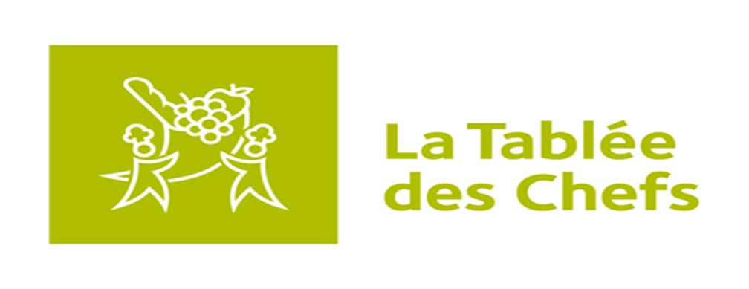**THE Kitchen brigades**

**(Grades 9-12)**

The Kitchen Brigades program consists of 12 culinary workshops, 3 culinary challenges and local, provincial and national iron chef type competitions. The 12 culinary workshops are held as extra-curricular activities from February to May and allow students to develop their culinary skills and food knowledge. The three culinary challenges focus on three main areas of teaching: community engagement, local food sourcing, and an international food fair.

This program will run each Wednesday after school beginning February 6 at Amherst Regional High School. There are only 16 spots available for this program so you must register as soon as possible if you are interested. For more information, contact Marvin Hairston (902) 694-8277.



Parrsboro Regional Elementary students build gingerbread houses during a weekly social group on December 12.

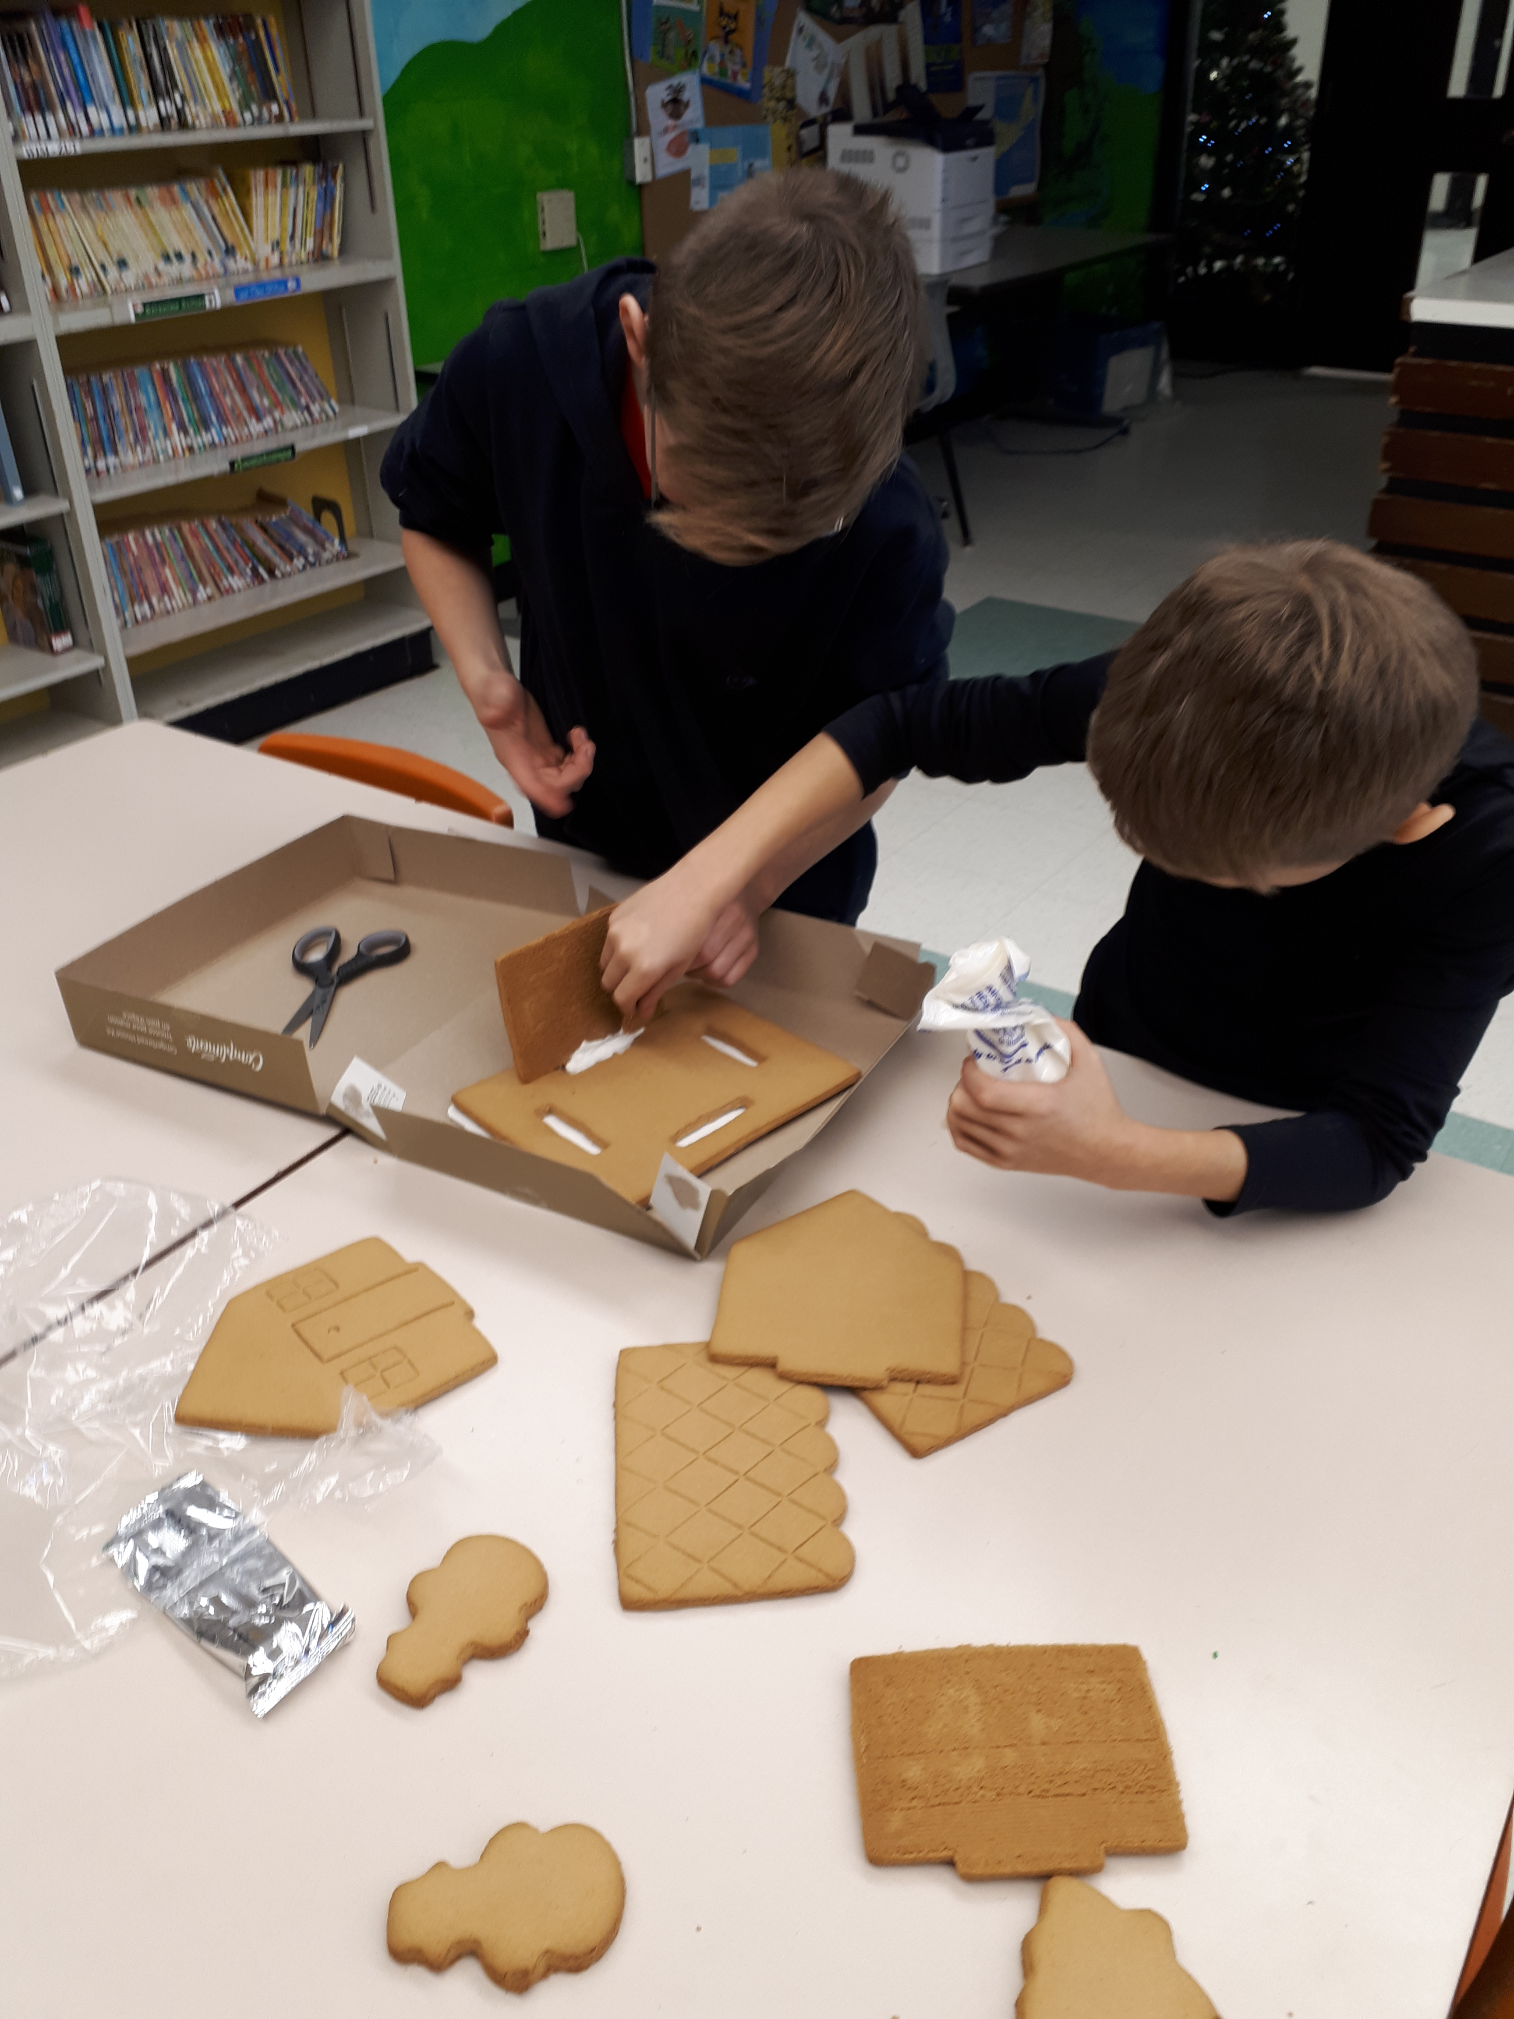

*This student enjoys a warm cup of hot chocolate while playing “Don’t Lose Your Cool”*

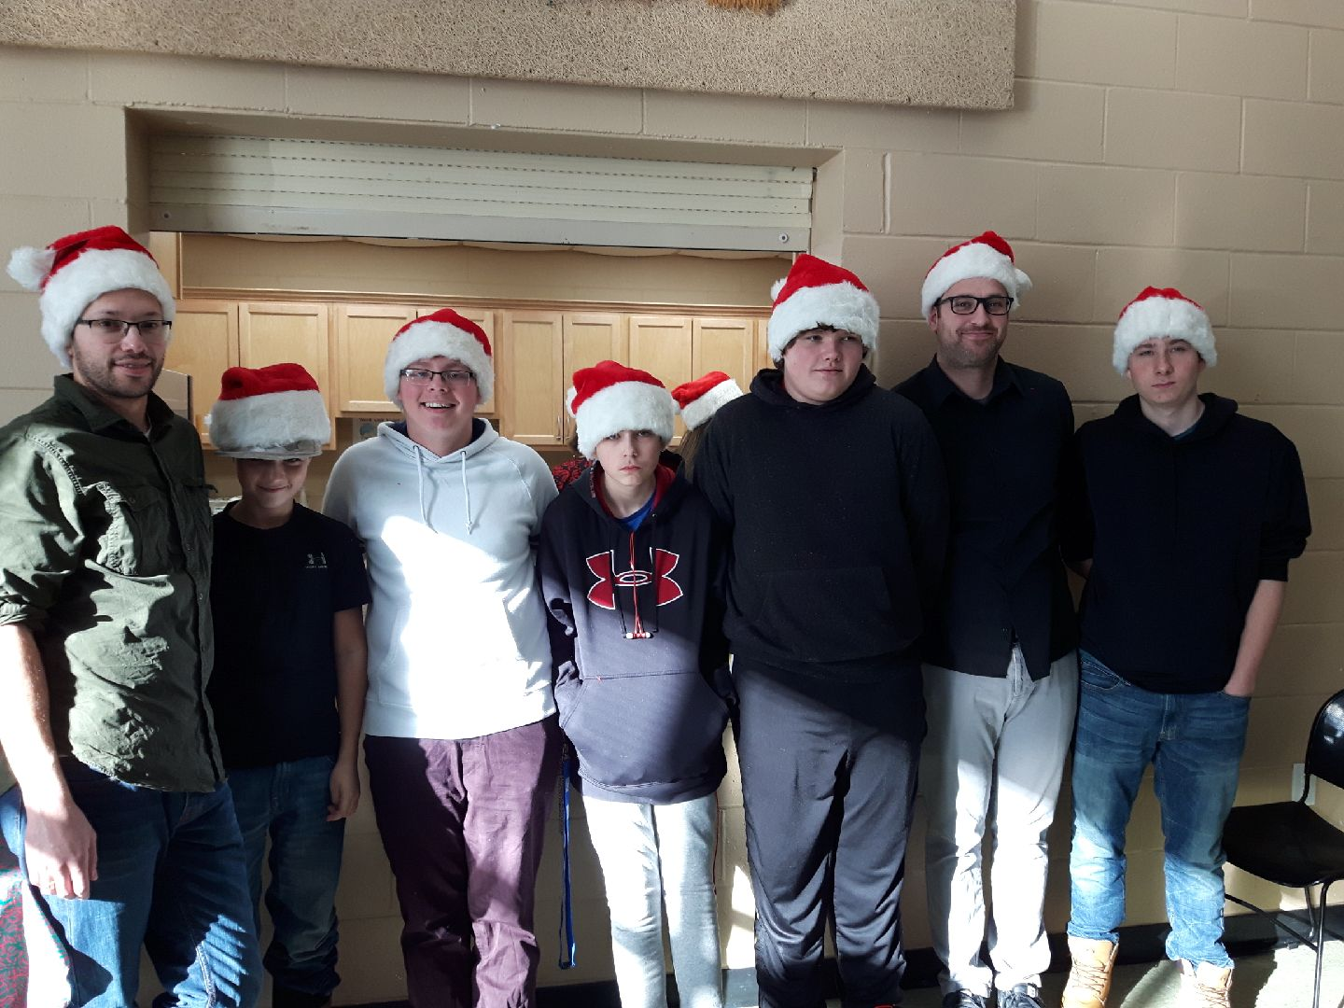

A group of junior high and high school students pose after giving a helping hand during the Cumberland YMCA Community Christmas Dinner on Wednesday, December 15 with the support of some SchoolsPlus staff.

**COMING SOON: FOOD CLUB AT NORTHPORT CONSOLIDATED ELEMENTARY**

**This 10 week cooking program will educate students around healthy food choices and safe food handling. Students will also document their learning through various media means. This program is scheduled to start on January 29 and will run each Tuesday from 2-4pm with Photographer, Catherine Bussiere.**

Amherst SchoolsPlus is currently running social groups at:

* **Northport Consolidated Elementary**
* **Parrsboro Regional Elementary**
* **Oxford Regional Education Centre**

**Voices (self-empowerment for girls) program**

The first 9 of 18 sessions for this program has been completed and the group will resume for the following 9 sessions in February. Dates and times to be determined. It will continue to be facilitated by the ARHS Youth Health Centre Nurse and SchoolsPlus Faciliator.



**Social groups are a great way for students to meet new friends, participate in new activities, and socialize in a safe supervised setting.**

www.facebook.com/amherstschoolsplus

JANUARY 2019

*Amherst SchoolsPlus Monthly Newsletter*



