Food Safety Course

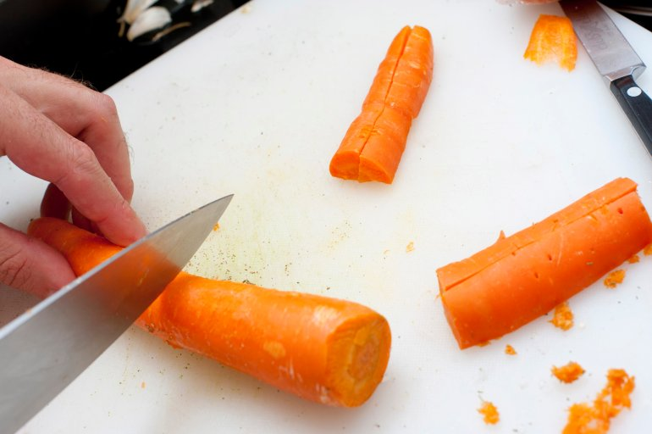
Interested in learning basics about food safety, handling, and storage for free?
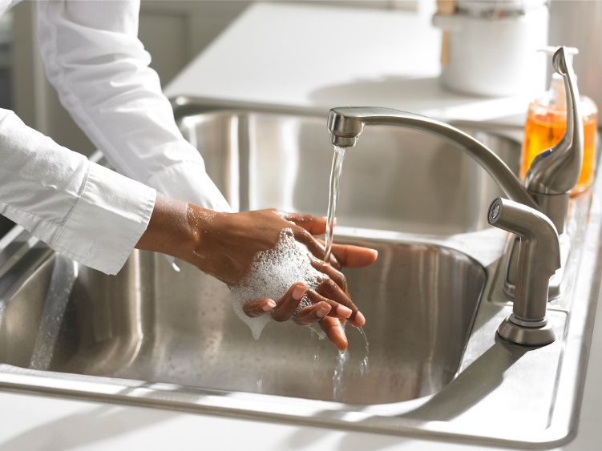

The food safety course is helpful for program staff interested in running small-scale cooking or meal preparation with groups in the community.
It is ideal preparation if you are delivering slow cooker programs, collective kitchen programs, or other group work (e.g. this course can benefit Family Resource Centers incorporating food/snacks into programs).
Session 2
March 23, 2018
Sherwood Park Education Centre (Rm 111)
500 Terrace St., Sydney
Time: 12:30 – 3:00

RSVP to reserve your spot by emailing Bridget Irwin at bridget.irwin@novascotia.ca
Session 1
March 21, 2018
Harbourview School (Rm 209)
25 Alfred St., Dartmouth
Time: 12 :30 – 3:00

