Cultural Beading Workshop
SchoolsPlus and the Mi’kmaw Aboriginal Student Support Worker will be hosting a Cultural
Beading Workshop for Grades 4 to 6 students who attend schools in Digby County.
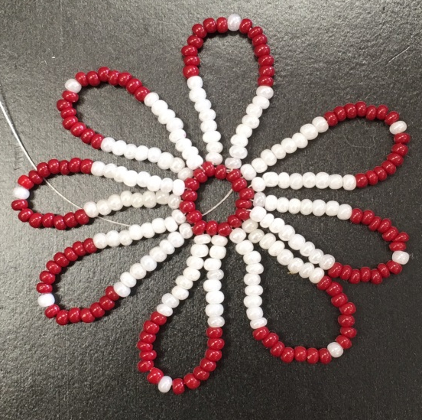

Date: Tuesday, March 13th, 2018

Time: 1:00 pm to 3:00 pm

Location: Digby Regional High School

Grades: 4 to 6
Maximum of 10 Participants!

To register, contact:

Amy Theriault at 902-245-7507
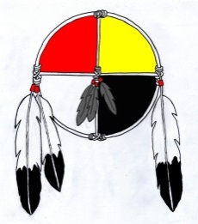
Janice Cromwell at 902-245-7524

(Registration on a first come, first served basis!

