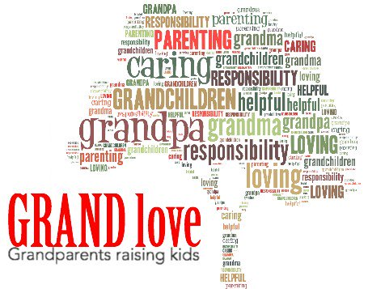
Name of Amazing GRANDPARENT Participant: _____________________________________
Mailing Address:
____________________________________________________ ____________________________________________________
____________________________________________________
E-Mail Address:
____________________________________________________
Phone Number:
____________________________________________________
Names and ages of Grandchildren: Childcare Needed:
______________________________________ Y / N
______________________________________ Y / N
______________________________________ Y / N
General Consent to Use Photograph
SchoolsPlus Annapolis, Annapolis Valley Regional Centre for Education, may take photographs of parents and students to showcase special events and activities that take place throughout the year. There may be times that SchoolsPlus will want to promote an event or achievement and use photographs in newsletters, news releases, Education Centres or Provincial SchoolsPlus web pages, displays or pamphlets.
Pursuant to the Freedom of Information and Protection of Privacy Act, Clause 26(b)
I, ________________________________, of _________________________________
do hereby give consent to SchoolsPlus Annapolis to approve the release of images.
Signature of Consent Adult _______________________________________________
Name of Child(ren) if Needed __________________________________________________
Dated: ________________________________________________________________

