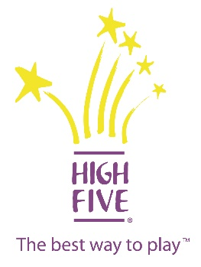

HIGH FIVE*: Principals of Healthy Childhood
Development Training
What is HIGH FIVE*?
HIGH FIVE® is Canada's quality standard for children's programs. Before HIGH FIVE, no standard existed and there was a clear need for an innovative approach to help organizations enhance program quality and provide positive experiences for children, which would remain with them for a lifetime
This all-day training will provide your staff with the understanding of the five principals to healthy childhood development, and ensure that your organization is providing Canada’s standard for children’s programs.
SchoolsPlus is a registered HIGH FIVE* organization with an available trainer who is ready to provide this incredible training to our partners. Other HIGH FIVE* registered organizations include: Boys and Girls Club, Halifax Rec, EXCEL, Canada Games Centre, Sports NS-Sport Development and many more organizations that provide programs to children.
You will learn the following principals developed by HIGH FIVE*:
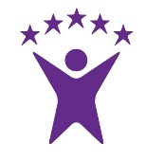
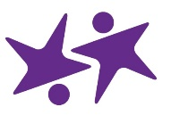
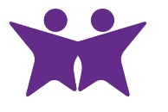
Participation
Mastery
Play
A Caring Adult
Friends

You will also learn HIGH FIVE*: Design Guidelines: DEVELOPMENTALLY APPROPRIATE, SAFE, WELCOMING OF DIVERSITY & INCLUSIVE.
Date: August 7, 2018
Time: 9:00am – 4:00pm
Location: Halifax Regional School Board, Room 310. 33 Spectacle Lake Drive.
Cost: Free
Please contact Dustin Boudreau by email at dustin.boudreau@hrsb.ca to register. Limited space is available.

