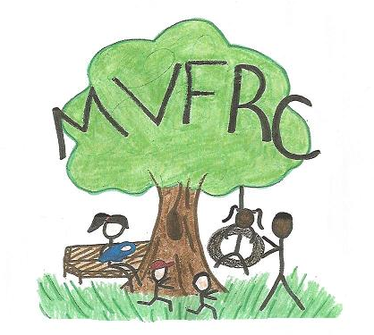

Incredible Years Parenting Course

SchoolsPlus in partnership with Musquodoboit Valley Family Resource Centre is offering
a FREE 12 week course for parents of 5 to 12 year olds

The course will focus on improving your child’s social and emotional skills and reducing behaviour problems.

Promoting healthy and happy family life.
Dates/Times: Starting on Tuesday evenings, February 5, 2019
6:30pm to 8:00pm weekly
Location: Musquodoboit Valley Family Resource Centre
12280 Hwy 224, Suite #2
Middle Musquodoboit, NS

Healthy Snacks will be provided.
If you are interested in attending this course but have some concerns,
please feel free to contact me to discuss it.

Advance registration is required as space is limited.

Please contact:

902-568-0042
mvfrcparentingjourney@gmail.com

