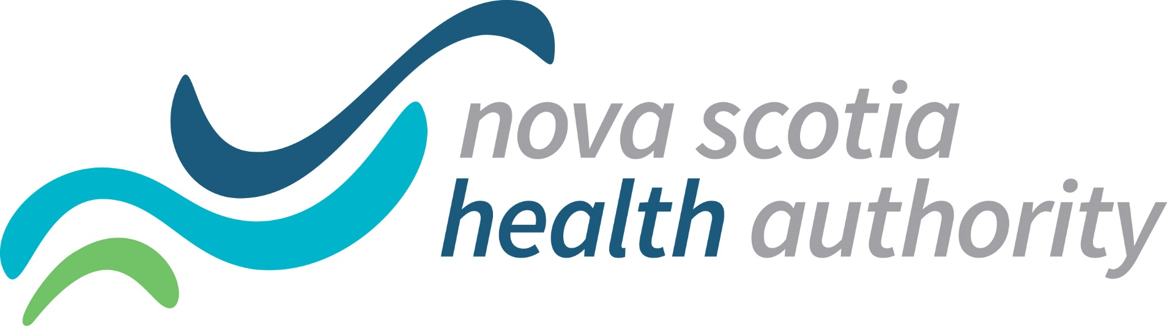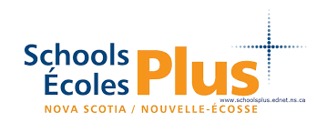

Dear Parent/Guardian

A FREE Summer Youth Program is being offered jointly by the Nova Scotia Health Authority Adolescent Outreach Staff and SchoolsPlus of the South Shore Regional Centre for Education.

We invite youth ages 9 and up to participate in this 3 day Camp offered one day per week in your area.

Camp Name: “Finding your Power Within”
Registration: FREE
Lunch, snacks and refreshments supplied
Dates:
Chester Area Middle School July 9, 16, and 30
Bridgewater Junior High School July 10, 17 and 31
North Queens Community School July 11, 18 and Aug 1st
Times: (9:30-2:30pm)

What are the goals:
FUN!!!
Activity
Friendships
Coping
Mindfulness
Emotions

Don’t let transportation be a barrier! If you want your child/ student to attend we will do our best to arrange transportation!

For more Information please contact the SchoolsPlus Facilitator for the area:
Linda Jensen 902 521 9817 (Parkview and New Germany Feeder Schools)
Colleen Myra 902 523 4360 (Forest Heights Feeder Schools)
Shannon Vincent 902 523 1451 (Queens County Schools)

