Free half-day
March Break program for _name of school_ students!

- Gym time, arts & crafts, games, and outdoor play.
- Small groups led by awesome HRCE CYCPs (Child & Youth Care Practitioners).
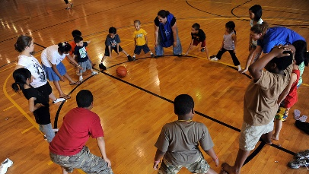
- Open to students in grades primary to 6

At ________ School – Monday to Friday, March 14 to 18
Students in grades P, 1, 2, 3: 9:00 to 11:30 AM
Students in grades 2, 3, 4, 5, 6: 12:30 to 3:00 PM

To register: Complete the atttached form and return it to school. Spaces are limited, so register as soon as possible. Deadline is Monday, March 7.
Questions? Contact your __school name__ Community Outreach Worker, ___ [name]___ (text or phone 902-___-____, or email ____@hrce.ca).

Nova Scotia COVID-19 Day Camp Protocols will be in place during this program.
If we have to cancel due to weather, SchoolsPlus staff will contact families by 8:00 am for morning programs, and by 11:30 am for afternoon programs.
See you March break!

